E-Commerce Customer Churn Analysis
Sona Varghese

Data Cleaning: (5 marks)
Handling Missing Values and Outliers:
➢ Impute mean for the following columns, and round off to the nearest integer if
required: WarehouseToHome, HourSpendOnApp, OrderAmountHikeFromlastYear,
DaySinceLastOrder.
Warehousetohome
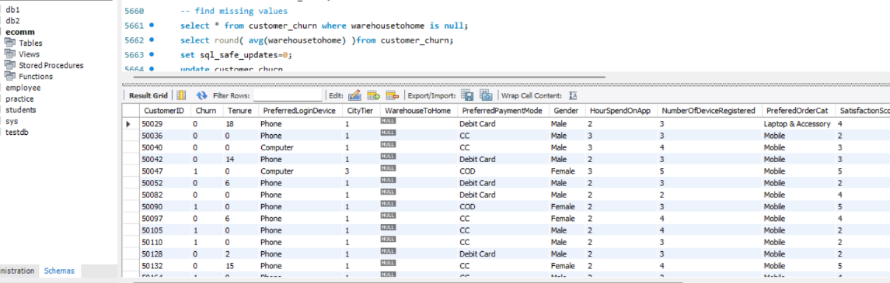
select round( avg(warehousetohome) )from customer_churn;
Average value is 16
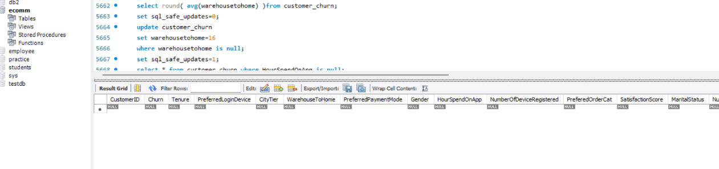
Hourspendonapp
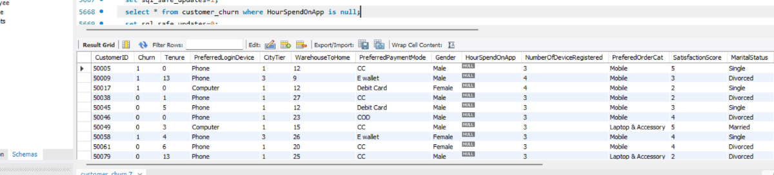
SELECT ROUND(AVG(hourspendonapp)) from customer_churn;
Average is 3
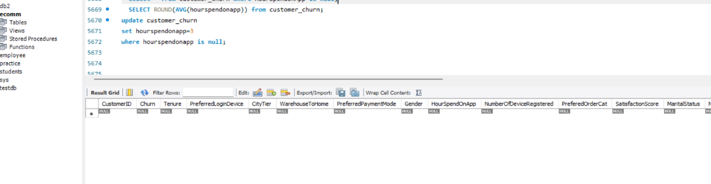
OrderAmountHikeFromlastYear
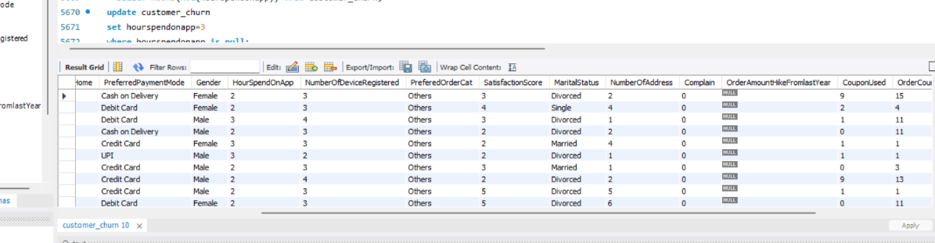
select round(avg(orderamounthikefromlastyear)) from customer_churn;
average is 16
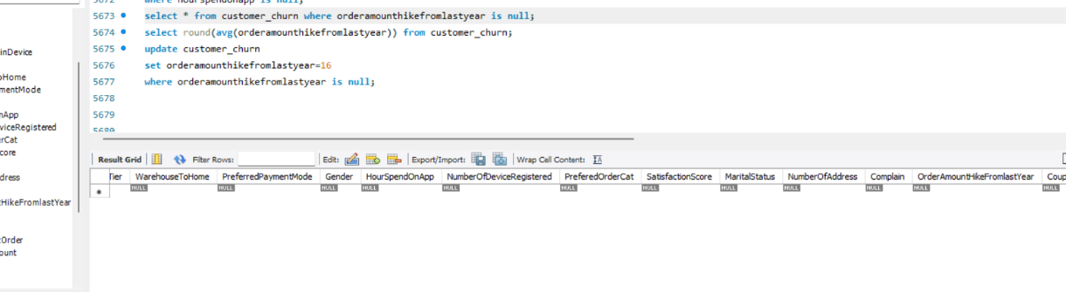
DaySinceLastOrder
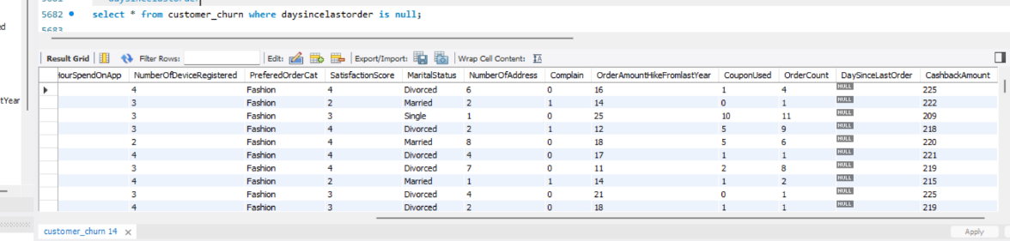
select round(avg(daysincelastorder)) from customer_churn;
average is 5
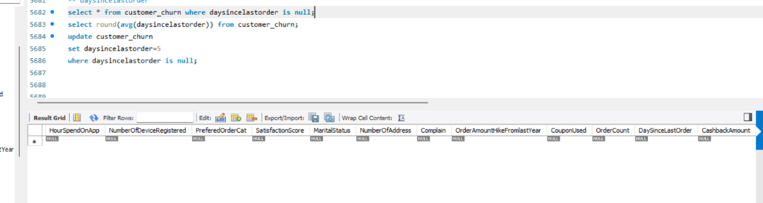
➢ Impute mode for the following columns: Tenure, CouponUsed, OrderCount.
Tenure
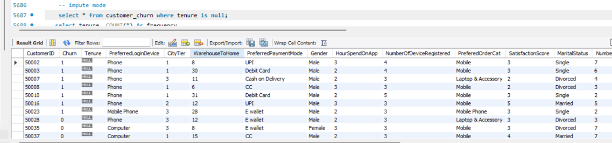
Mode
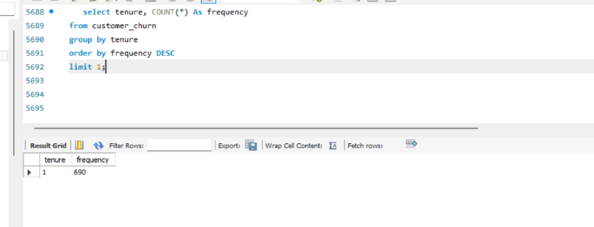
update customer_churn set tenure=1
where tenure is null;
Couponused
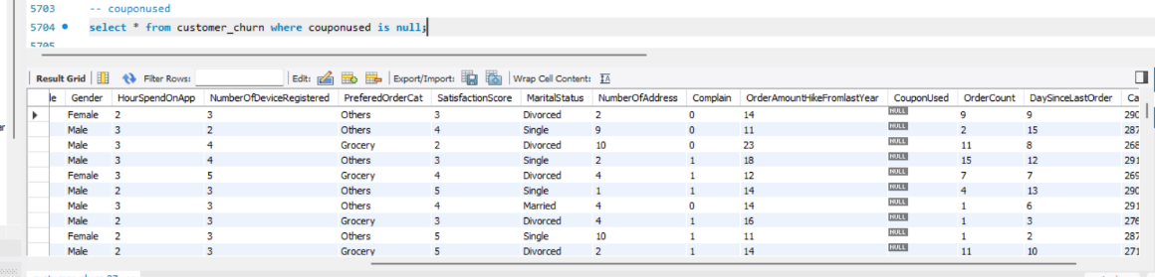
Mode
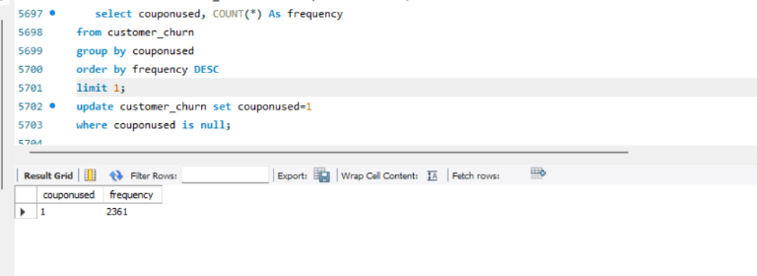
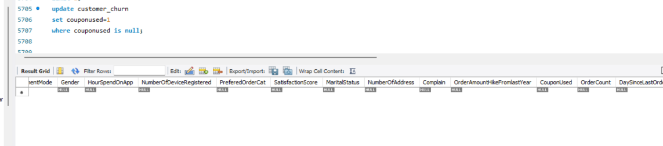
Ordercount
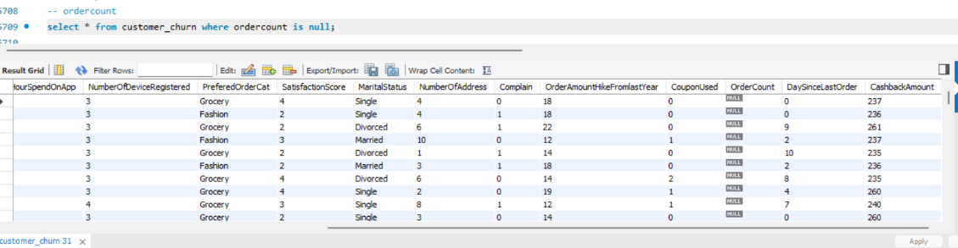
Mode

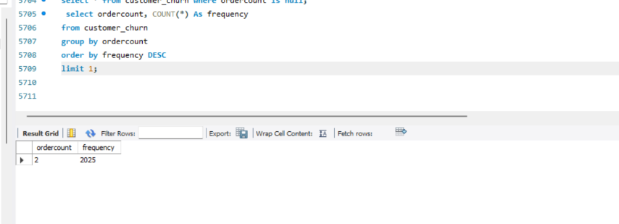
➢ Handle outliers in the 'WarehouseToHome' column by deleting rows where the
values are greater than 100.
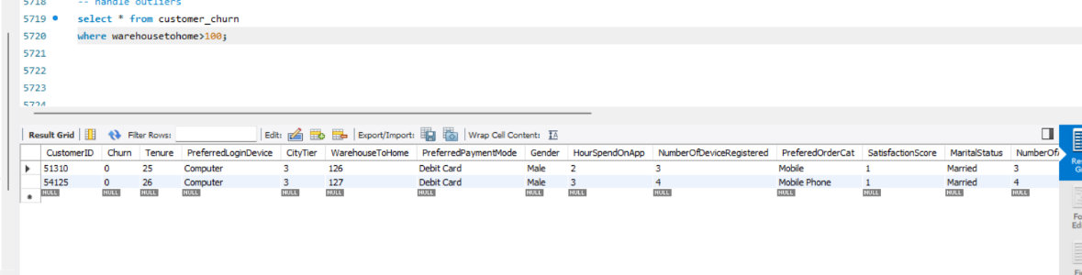
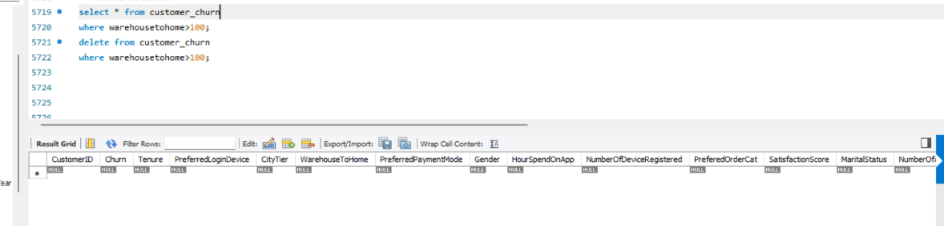
Dealing with Inconsistencies:
➢ Replace occurrences of “Phone” in the 'PreferredLoginDevice' column and
“Mobile” in the 'PreferedOrderCat' column with “Mobile Phone” to ensure
uniformity.
Preferredlogindevice
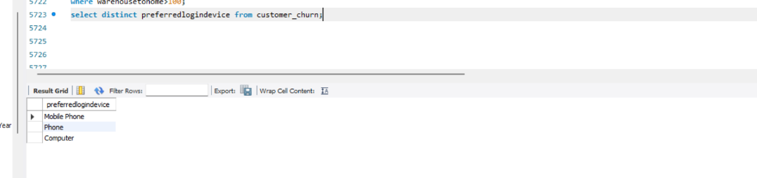
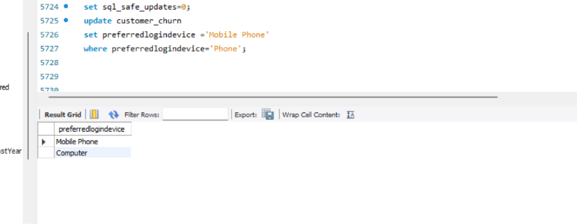
Preferredordercat
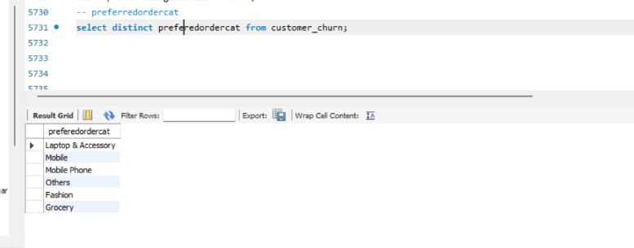
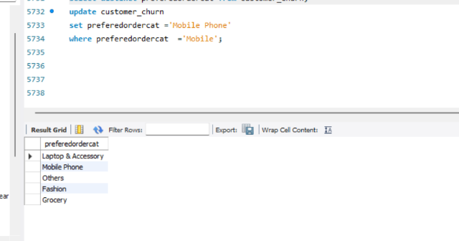
➢ Standardize payment mode values: Replace "COD" with "Cash on Delivery" and
"CC" with "Credit Card" in the PreferredPaymentMode column.
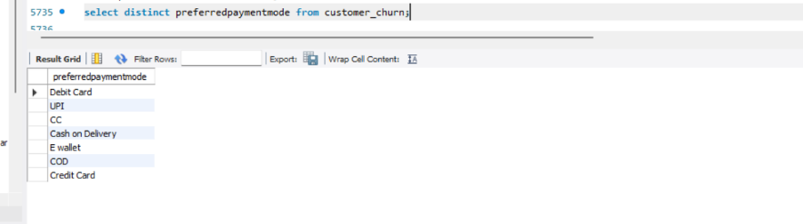
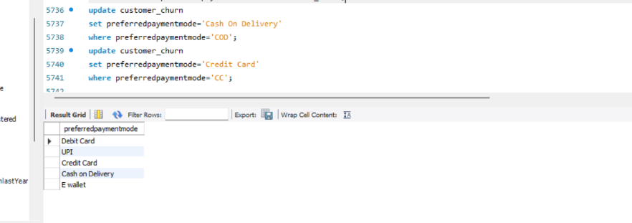
Data Transformation: (3 marks)
Column Renaming:
➢ Rename the column "PreferedOrderCat" to "PreferredOrderCat".
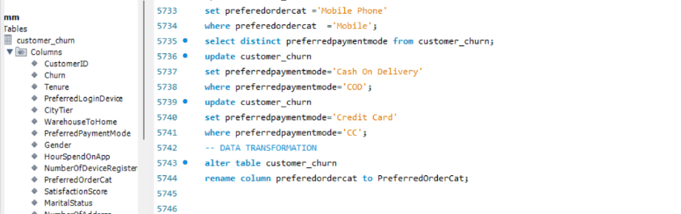
➢ Rename the column "HourSpendOnApp" to "HoursSpentOnApp".
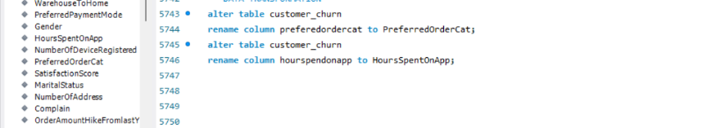

Creating New Columns:
➢ Create a new column named ‘ComplaintReceived’ with values "Yes" if the
corresponding value in the ‘Complain’ is 1, and "No" otherwise.
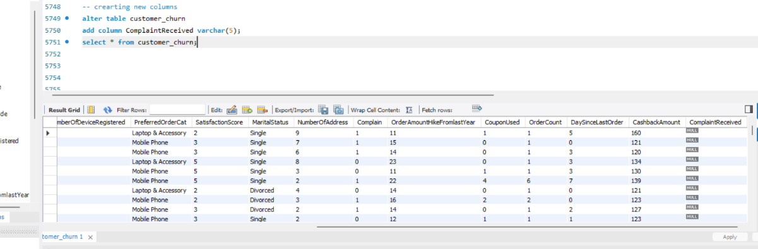
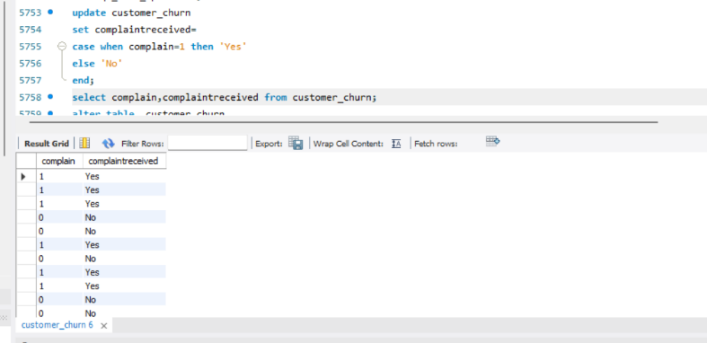
➢ Create a new column named 'ChurnStatus'. Set its value to “Churned” if the
corresponding value in the 'Churn' column is 1, else assign “Active”.
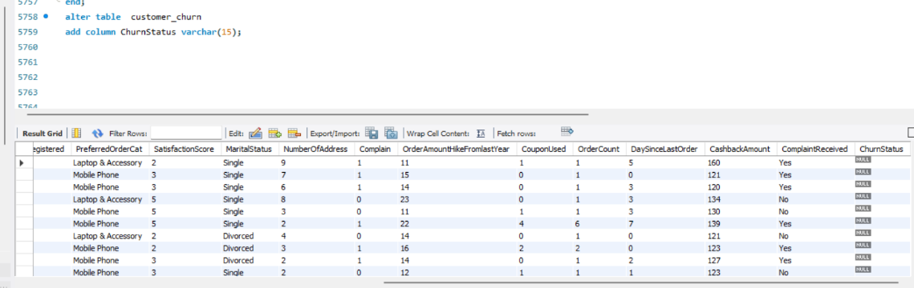
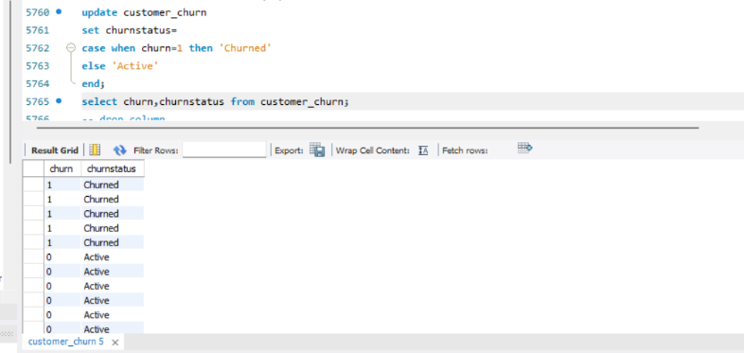
Column Dropping:
➢ Drop the columns "Churn" and "Complain" from the table.
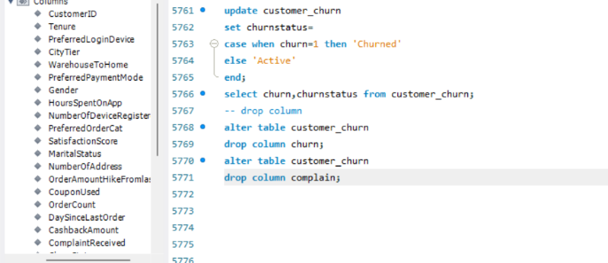
Data Exploration and Analysis: (17 marks)
➢ Retrieve the count of churned and active customers from the dataset.
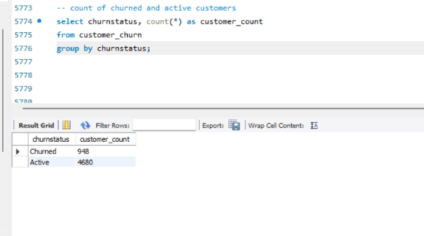
There were 948 churned customers and 4680 active customers.
➢ Display the average tenure and total cashback amount of customers who
churned.
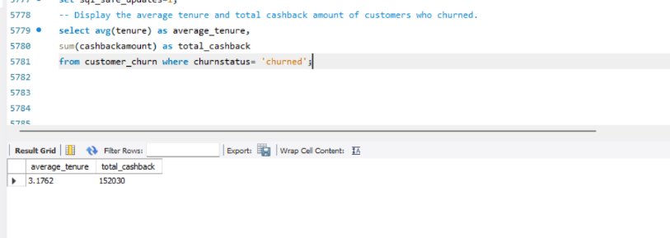
The average tenure of customers who churned is 3.1762 and total cashback amount is 1520.30.
➢ Determine the percentage of churned customers who complained.
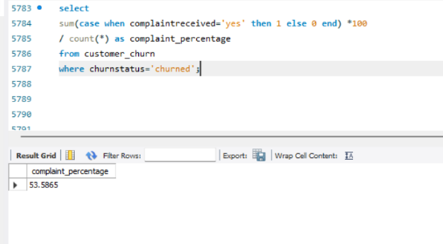
The percentage of churned customers who complained is 53.5865.
➢ Identify the city tier with the highest number of churned customers whose
preferred order category is Laptop & Accessory.
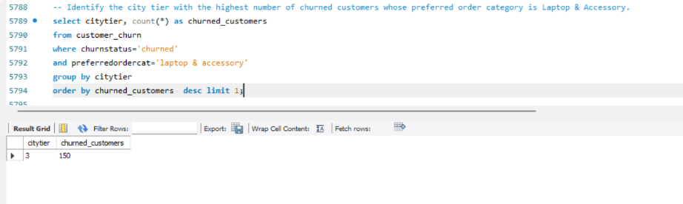
City tier 3 has the highest number of churned laptop and accessory customers with 150 customers.

➢ Identify the most preferred payment mode among active customers.
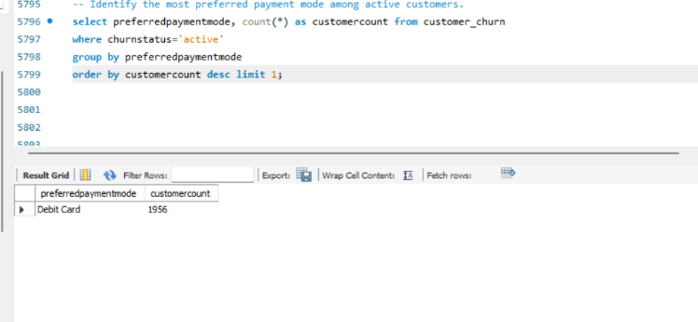
The most preferred payment mode among active customers is debit card , showing customers mainly use this payment method for their purchases.
➢ Calculate the total order amount hike from last year for customers who are single
and prefer mobile phones for ordering.
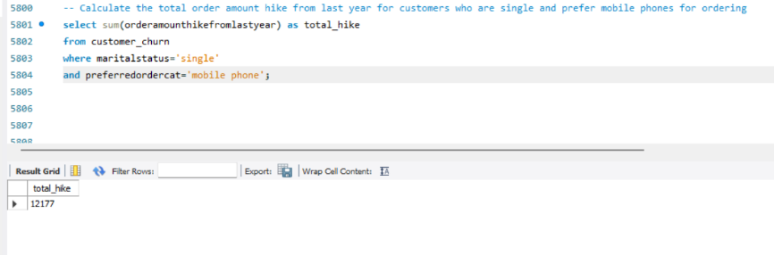
Single customers who prefer mobile phone have a total order amount hike of 12.177 compared with previous year.
➢ Find the average number of devices registered among customers who used UPI as
their preferred payment mode.
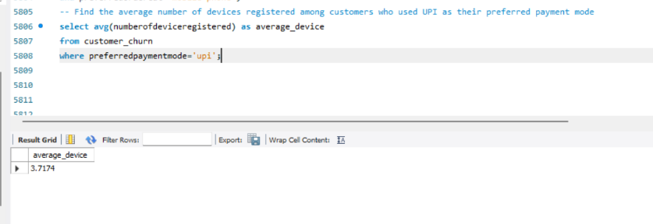
Customers using upi have an average of 3.7174 registered devices, indicating the typical number of devices associated with upi users.
➢ Determine the city tier with the highest number of customers.
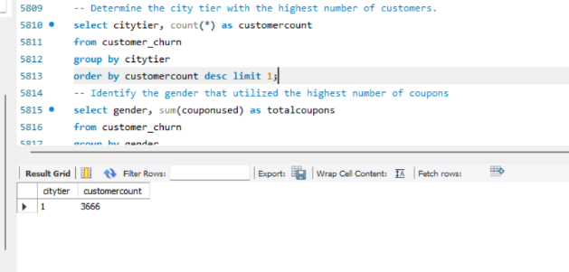
City tier 1 has the highest number of customers, indicating that this tier represents the largest customer segment in the dataset.
➢ Identify the gender that utilized the highest number of coupons.
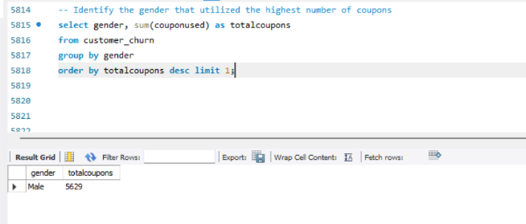
Male gender has used the highest total number of coupons
➢ List the number of customers and the maximum hours spent on the app in each
preferred order category.
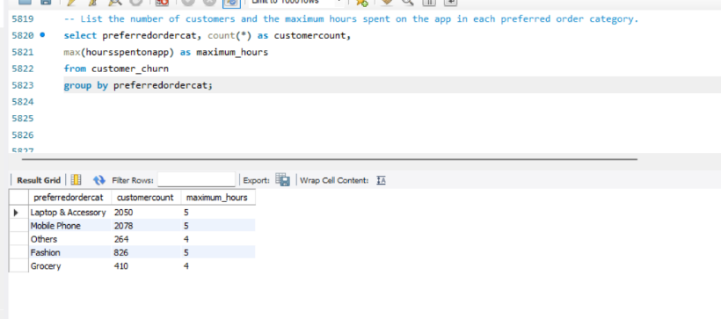
The mobile phone category has the highest number of customers.
➢ Calculate the total order count for customers who prefer using credit cards and
have the maximum satisfaction score.
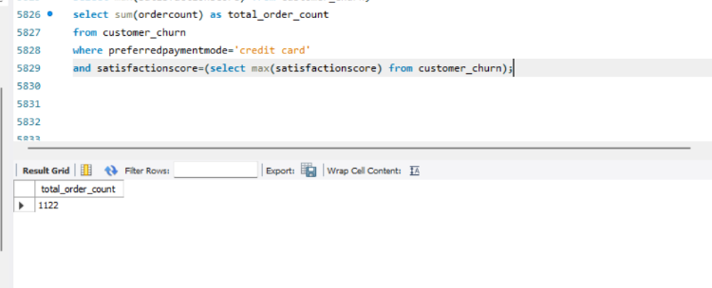
Customers using credit card with the maximum satisfaction score have placed a total of 1122 orders.
➢ What is the average satisfaction score of customers who have complained?
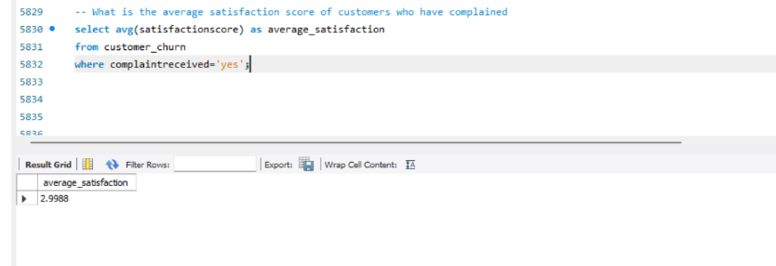
Customers who submitted complaints have an average satisfaction score of 2.9988.
➢ List the preferred order category among customers who used more than 5
coupons.
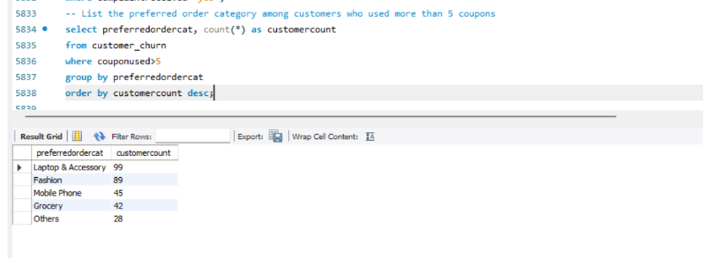
➢ List the top 3 preferred order categories with the highest average cashback
amount.
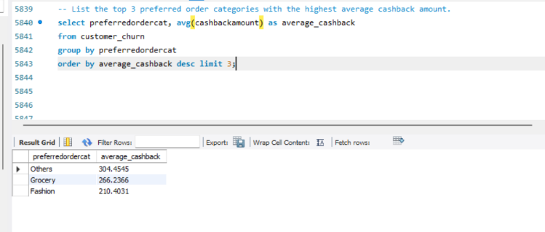
The top three categories based on average cashback are others, grocery and fashion. Others has the highest average cashback among them.
➢ Find the preferred payment modes of customers whose average tenure is 10
months and have placed more than 500 orders.
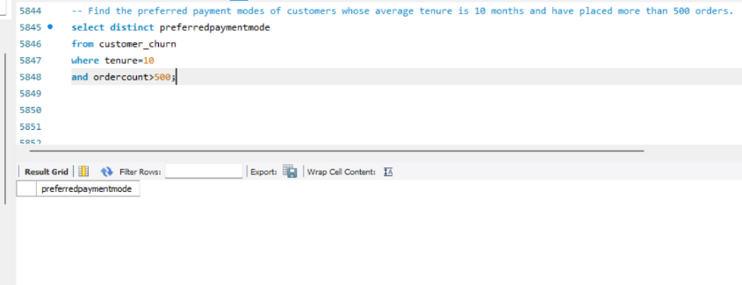
The analysis shows that there is no payment modes meeting the specified criteria.
➢ Categorize customers based on their distance from the warehouse to home such
as 'Very Close Distance' for distances <=5km, 'Close Distance' for <=10km,
'Moderate Distance' for <=15km, and 'Far Distance' for >15km. Then, display the
churn status breakdown for each distance category.
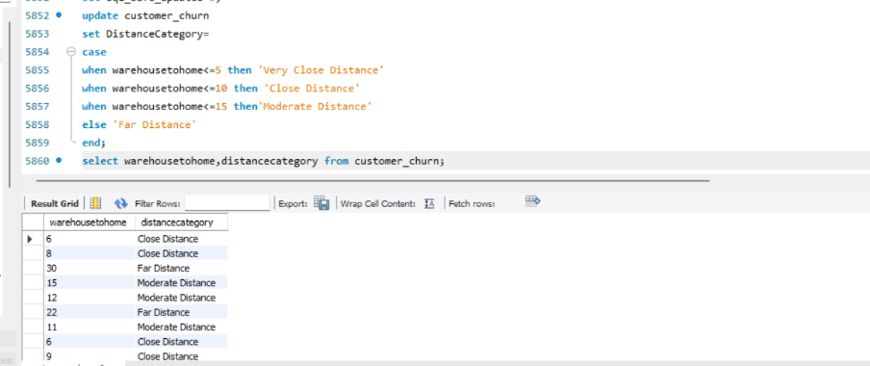
➢ List the customer’s order details who are married, live in City Tier-1, and their
order counts are more than the average number of orders placed by all
customers.
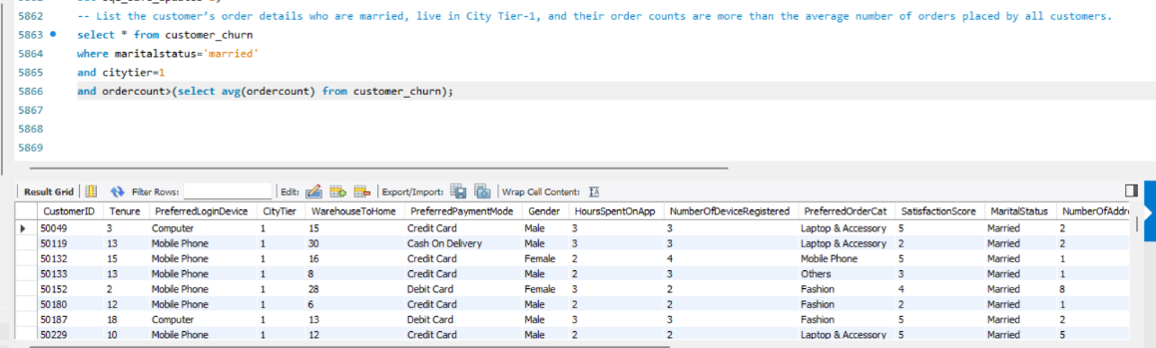
576 rows exists.

a) Create a ‘customer_returns’ table in the ‘ecomm’ database and insert the
following data:

ReturnID CustomerID ReturnDate RefundAmount
1001 50022 2023-01-01 2130
1002 50316 2023-01-23 2000
1003 51099 2023-02-14 2290
1004 52321 2023-03-08 2510
1005 52928 2023-03-20 3000
1006 53749 2023-04-17 1740
1007 54206 2023-04-21 3250
1008 54838 2023-04-30 1990
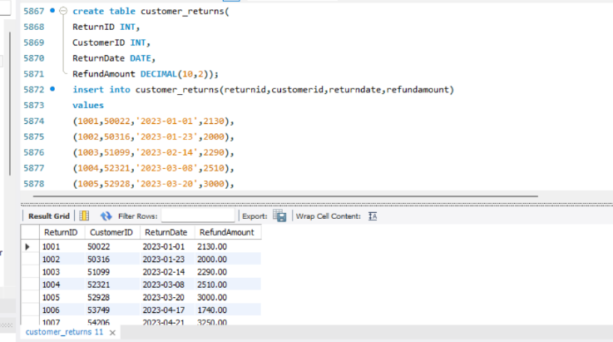

b) Display the return details along with the customer details of those who have
churned and have made complaints.
